Columbian Exchange

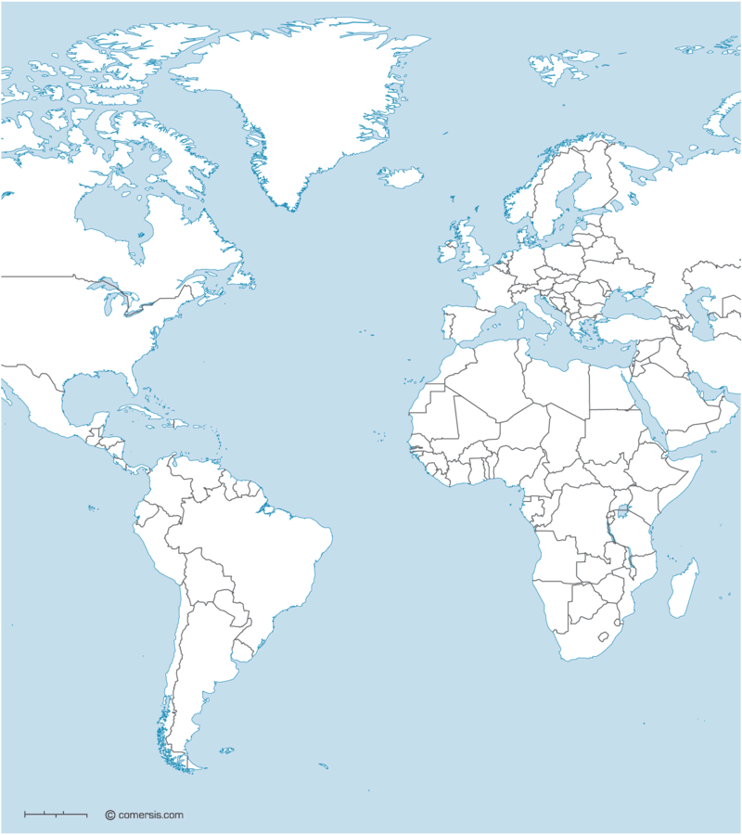

Atlantic Slave Trade






